**Numerical Investigation of Cooling of Electronic Servers Racks at Different Locations and Spacing from the Data Center Cooling Unit**

**S.A. Nada†, M.A. Rady‡, M. Elsharnoby† and M. A. Said†\***

**†**Department of Mechanical Engineering, Benha Faculty of Engineering, Benha University, Benha, P.O. 13511, Egypt

**‡**Mechanical Engineering Department, Faculty of Engineering at Helwan University, Helwan, P.O. 11421, Egypt

Accepted 16 Oct 2015, Available online 25 Oct 2015, **Vol.5, No.5 (Oct 2015)**

***Abstract***

*The racks and perforated tiles locations and spacing with respect to the computer room air conditioning (CRAC) unit can be considered as one of the data center design parameters that may affect the thermal management of the racks servers. In this paper A CFD numerical investigations of the effects of the racks location in the rack row and the spacing between the CRAC unit and the rack row on air flow, temperature distribution and thermal management of the racks servers are presented. Measureable overall performance parameters: supply/return heat indices (SHI/RHI), return temperature indices (RTI) and return cooling indices (RCI) are used to evaluate the thermal management of the servers racks. A typical racks row of seven racks of power density of 3.5 kW per rack and 25% opening ratio of the perforated tiles are considered in this study. Techniques of using cold aisle containments for enhancing the cooling effectiveness of data centers is investigated and evaluated. The results showed that (i) the location of the rack in the racks row strongly affect the thermal management of the rack servers, (ii) changing the spacing between the CRAC units and cold aisle slightly affect the air recirculation and bypass around the racks, and (iii) using appropriate cold aisle containment improves the performance of cooling of data centers.*

***Keywords:*** *Data centers; CFD numerical investigations; thermal management enhancement; aisle containments*

**Nomenclature**

|  |  |
| --- | --- |
| [1] Cp | specific heat of air at constant pressure (J/kg. k) |
| CRAC | Computer Room Air Conditioning |
| $$\dot{m}$$ | mass flow rate ($kg/s$) |
| T | temperature (◦C) |
| Tref | reference temperature (◦C) |
| Q | total power dissipation from data center components (W) |
| U | velocity (m/s) |
| RHI | return heat index |
| RCI  RTI  SHI | return cooling index  return temperature index  supply heat index |
| **Superscripts** | |
| r | rack |
| c | CRAC |
| **Subscripts** | |
| in | inlet |
| out | outlet |
| ref | CRAC supply |
| max-rec | maximum recommended / ASHRAE TC9.9 (2008) |
| max-all | maximum allowable / ASHRAE TC9.9 (2008) |
| min-rec | minimum recommended / ASHRAE TC9.9 (2008) |
| min-all | minimum allowable / ASHRAE TC9.9 (2008) |
| Return | return air |
| Supply | supply air |

**1. Introduction**

Air recirculation and air bypass around the server’s racks are the main problems to reliable operation and energy consumption of data centers. With an open aisle configuration (Fig. 1), air recirculation from the back to the front of the rack is expected and causes non-uniformity in air temperature distribution entering the rack.

Therefore, some servers will receive cold air (bottom servers) and other servers may receive hot recirculated air (edge and top servers) resulting in the server's inlet air temperature exceeding the recommended limit (27 °C). The distribution and uniformity of the air flow through the perforated tiles of the data is governed by several factors such as plenum size, presence of flow obstructions such as cables and pipes in plenum space, locations of CRAC units with respect to the racks, layout of the perforated tiles and the tiles size, opening area and flow resistance.



**Figure 1:** Example of a typical data center (K. Karki *et al*, 2003)

These factors affect the pressure distribution in the plenum space and control the flow through the perforated tiles of the data center. The racks and perforated tiles locations with respect to the CRACs units can be considered as one of the data center design parameters that may affect the thermal management of the data center racks. Also the spacing between the CRACs and the racks rows may affect the thermal managements of the data center racks.

Most of the recent data centers studies are devoted to enhance the design to solve the recirculation problem. There is a recent interest in predicting the air thermal distribution using the available CFD tools. A few of these studies were validated against experimental data of detailed air temperature distribution in data centers. An early study on floor tile airflow was performed by (S. Kang *et al*, 2000). The study showed that a simple model of the volume under the raised floor using the technique of flow network modeling (FNM) can predict the distribution of flow rates exiting from the various tiles. (Schmidt *et al*, 2001) studied the effect of raised-floor plenum height and perforation area on airflow rates through the perforated tiles with different arrangement of data center using measurements and predictions via a compact model. (K. Karki *et al*, 2003) presented a computational fluid dynamics model for calculating airflow rates through perforated tiles in raised-floor data centers. The model was based on the assumption that the pressure in the space above the raised floor is uniform, which limited the calculation to the space below the raised floor. (W.A. Abdelmaksoud *et al*, 2012) showed that the strongest factors influencing and improving the data centers CFD simulation results are the inclusion of correct tile flow model, buoyancy, and realistic turbulent boundary conditions. A practical tile flow model (momentum source model) was developed to correct for the global values of both mass and momentum of the jets issuing from the perforated tiles. (S. Kim, 2009) conducted a study on the flow distribution in data centers for two of the most promising types of the floor tiles; fan-assisted tiles and tiles with louvers. The fan-assisted tile was sits under a traditional perforated tile in order to enable a variable local tile flow rate. The study recommended that the active tile can be used with a control system to avoid hot spots by varying the local flow rate at a particular rack location depend on a monitored temperature or some other variable. (Karki and Patankar, 2005; Karki *et al*, 2003) studied the effects of the plenum size and the open area of the perforated tiles on the airflow distribution using an idealized one-dimensional computational model and other various techniques. (R. K. Sharma, 2002) studied the effects of cold aisle and hot aisle widths and ceiling space on data centers thermal performance. The study showed data centers can be optimized not only based on geometric parameters but also based on heat loads using the non-dimensional parameters supply heat index (SHI) and return heat index (RHI) to evaluate the thermal design and performance. (R.R. Schmidt, 2004) conducted a study focuses on the effect on rack inlet air temperatures as a result of distribution of airflows exiting the perforated tiles located adjacent to the racks fronts. The flow distribution exiting the perforated tiles was generated from a computational fluid dynamics (CFD) tool called Tile flow (trademark of Innovative Research, Inc.). Both raised floor heights and perforated tile-free areas were varied in order to explore the effect on rack inlet temperatures. (J. Cho *et al*, 2009) numerically studied the design parameters and IT environmental aspects of the cooling system in a high heat density data center. CFD simulation analysis was carried out in order to compare the heat removal efficiencies of various air distribution systems. (S. Bhopte *et al*, 2006) studied the effect of plenum depth, floor tile placement and ceiling height on data center air flow distribution and rack inlet air temperature for 12 kW racks power density. (K. Zhang *et al*, 2014) studied air flows characteristics of under-floor air distribution (UFAD) system through plenum and perforated tiles in a plenum test facility. (J.F. Karlsson *et al*, 2005) used an infrared camera to visualize the airflow and temperature pattern, showing that cool air does not reach the upper levels of the racks, despite a very high air exchange rate. Point measurements of temperatures in a rack showed that recirculation cells are present, causing accumulation of heat and improper cooling of electronic equipment. Thus, the chilled air is not distributed properly and consequently the cooling energy is not used effectively. (H.S. Sun *et al*, 2006) addressed the issue of energy performance of data centers by closely examining energy use of two data centers in commercial office buildings. The study concluded that data centers were high energy consuming areas in commercial office buildings. Power demands were often grossly over-provided in these facilities. In one case study, approximately 56% (1.2 GWh/year) of energy consumption could be conserved through efficient designs of base infrastructure and energy consuming systems, as compared to better practice. ([J. M. Jackson](http://www.sciencedirect.com/science/article/pii/S0360544203000094) *et al*, 2003) examined some of the reasons why power requirements at data centers are overstated and added actual measurements and the analysis of real-world data to the public policy debate over how much energy these facilities use. Measureable overall performance parameters: supply/return heat indices (SHI/RHI), return temperature indices (RTI) and return cooling indices (RCI) were introduced and used in many studies and investigations to measure the temperature and flow distributions effectiveness and evaluate the thermal management of the individual racks and entire data centers. Recently, (S.A. Nada *et al*, 2015) experimentally studied the effects of the servers power loading schemes and power distribution on SHI/RHI, RTI and RCI and the thermal management of the different racks in a rack row of a data center.

The above literature illustrates that many researches have included the under floor plenum in the CFD simulation in order to investigate the perforated tile air flow distribution assuming a constant pressure boundary condition above the perforated tiles as it was argued that the pressure variations inside the data center room are very small compared with the pressure drop through the perforated tiles. Other researchers have modeled the plenum only without simulating above the floor and studied the effect of perforation area and plenum height on air flow distribution.

Detailed comprehensive study on the effects of racks and CRAC locations and spacing on the air distribution, temperature distribution and thermal management in data centers above floors are not available. In the present paper, the effects of data centers racks and CRACs locations and spacing and the arrangement of using cold aisle containment on the air flow characteristics and thermal performance of the data centers are investigated. Supply/return heat indices (SHI/RHI), return temperature indices (RTI) and return cooling indices (RCI) are used as measureable overall performance parameters of air flow and thermal management of data centers.

**2. Physical model**

A small raised floor data center room of dimensions 6.71 m × 5.49 m × 3.0 m was considered as the physical model of the present study. The data center contains 14 servers racks arranged in two rows with a spacing 1.22 m between the two rows.



**Fig. 2** CFD data center physical model

The racks are arranged to be at 1.22 m distance from the room wall. Fourteen perforated tiles are used in the cold aisle to provide the supply cold air to the 14 racks. The hot air discharged from the rack servers flows out from the room through ceiling vents. Six ceiling air outlet (three in each hot aisle between each row of rack and the room wall) are used for this purpose.

Two computer rooms air conditioning units (CRAC) are used, one in each side of cold aisle tiles row. The CRACs discharge the cold air at 12 °C to the plenum underneath the raised floor. Typical raised floor plenum of depth 0.6 m and perforated tiles of size 0.6 m x 0.6 m are used. The data center CFD modeling was firstly model the distribution of air flow rates in raised floor plenum and the tiles and then the modeling the data center starting from the perforated tiles exporting the velocity components in perforated tiles from the plenum and tiles modeling. Figure 2 gives full details of the physical model; the dashed lie in section A-A represent cold aisle compartment that will be proposed in section 4-1 for data center thermal enhancement.

In order to avoid complicated meshing of detailed perforations in tiles, the simplified accurate momentum source method proposed by (W.A. Abdelmaksoud *et al*, 2012) was used in the present CFD model. The momentum source method corrects the momentum deficit of flow going through a fully open tile by adding a body force field in the computational volume directly above the tile. This corrects the fully open tile model to more accurately resemble a perforated tile. The required body force is calculated as follows:

$F=\frac{1}{V} ρQ\left(\frac{Q}{σ A tile}-\frac{Q}{A tile}\right)$ (1)

Where V is the computational volume that applies the body force field, ρ is the air density, Q is the air flow rate through fully open tile, σ is the tile perforation factor (e.g. 0.25 for 25% perforation) and Atile is the area of the fully open tile. Therefore, a computational volume of 0.534 m × 0.534 m × 0.01 m was considered above each perforated tile and the body force was calculated using Eq. 1.

The DC model contains fourteen racks arranged in two rows of seven racks. A typical rack dimension (W×D×H) of 0.610 m × 0.915 m × 2.0 m is considered. Each rack is further subdivided into four server chassis of dimensions 0.610 m × 0.915 m × 0.5 m. To model the heat generation within the servers, a boundary heat generation was considered at the boundary of each server. The flow through the server is modeled by specifying a fixed mass flow rate into and out of each server. A typically perforation factor of 0.35 was assumed for each rack; therefore, a momentum source, similar to that used for the tile, was placed behind each server. The computational volume for the server body force field is 0.610 m × 0.500 m × 0.0763 m. The CFD models was meshed using tetrahedron elements using Gambit software. The elements were refined near the perforated tiles, server inlets and outlets, and room outlets.

**3. Mathematical formulation**

This section introduces the governing equations and boundary conditions used to simulate the fluid flow and heat transfer in a data center thermal model. In order to model the flow in a domain on the scale of a data center, turbulent transport must be included. The resulting coupled partial differential equations with complex boundary conditions are solved numerically using the finite volume discretization method in the three-dimensional data center computational domains.

*3.1 Governing Equations and Numerical Solution Techniques*

Mass, momentum and energy conservation equation applied on infinitesimal fixed control volume are derived. In order to model the flow in a domain on the scale of a data center, turbulent transport is included.

 (2)

 (3)

 (4)

 (5)

 (6)

The obtained non-linear coupled equations are solved in order to determine the flow, pressure, and temperature distributions in space and time. These equations are typically solved by using numerical techniques for most problems of any significant complexity. These techniques typically reduce the differential equations to algebraic ones which are then solved for a finite number of grid points in the flow field. Because of the low Mach number (<< 0.3) nature of the data center flow environment, the air can be treated as incompressible flow (constant density); in addition, the effects of natural convection are not considered. In a typical data center domain, the air enters the plenum from the CRAC and circulates through the plenum and the room volume and returns to the CRAC so that the air volume is constant. Under these assumptions, conservation of mass, momentum and energy reduces to eq.2, 3, 4, 5 and 6

Where T is the temperature and *Pr* is the Prandtl number.

The above system of equations is solved numerically under the boundary conditions of the problem. Table 1 summarizes the boundary conditions for the data center CFD model. The heat generation is determined from the server flow rate and prescribes the temperature difference of the air flowing through the server (approximately 10.19 ◦C (R. Schmidt *et al*, 2001)). The simulation was run using CFD-Fluent-Solver. All simulations were run with the k-Epsilon turbulence model. The convergence criterion for the root mean square values of the equation residuals was set to 0.001. Each simulation converged in roughly 12 hours on a computer with Intel Core i7-620M processor. Once the solution was complete, the results were analyzed on CFD-Post. The two commercial CFD packages ANSYS FLUENT 14 and grid-generation software GAMBIT 2.4.6 are used for data processing, analysis and presentation.

**Table 1:** Boundary Conditions of the Model

|  |  |  |  |
| --- | --- | --- | --- |
| **Boundary condition** | **Symbol** | **Equation** | **Value** |
| Inlet airflow velocity | U0 | - | 1 ms-1 |
| Tile flow rate | Qt | Qt= U0 Atile | 0.294 m3s-1 |
| Inlet air temperature | T0 | - | 12 ◦C |
| Server flow rate | Qs | Qs= Qt/4 | 0.0735 m3s-1 |
| Server heat generation | Ps | Ps=ρ cp Qs ΔT | 875 W |
| Tile porosity | σt | - | 25% |
| Rack porosity | σr | - | 35% |

*3.2 Data Center Performance Parameters Indices*

Several non-dimensional key parameters were used in the literature as scalable indices of performance parameters for data centers. The key measure index of data center cooling arrangement is the temperature distribution. Any data center component such as computer rack, vent tile, CRAC,. etc can be characterized by inlet and outlet temperature. Thus, all the indices of performance parameters are based on inlet and outlet temperatures and a reference fixed temperature (typically CRAC supply temperature). Enhancement of data center performance means minimize air recirculation (infiltration of hot air into the cold aisles), minimize cold air bypass (mixing of cold air with the return hot air streams prior to return to the CRAC units) and minimize the short-circuiting of cold air to the CRAC inlet. Three key indices: rack cooling index (RCI), supply and return heat indices (SHI & RHI), and return temperature index (RTI) are used in the literature as indices of data centers performance.

The work in which RCI was firstly introduced was carried out by (Magnus K. Herrlin, 2009). This index is associated to the rack inlet temperatures, which is the condition required by the IT server for continuous operation (see Fig. 3). The allowable and recommended ranges for intake temperature represent the design conditions, while the recommended limits refer to the preferable facility operation (Magnus K. Herrlin, 2009). Two RCIs, namely RCIHI and RCILO, are used to describe the servers intake temperatures to the high and the low ends of the temperature range, respectively. The RCIHI measures the difference of over-temperatures and The RCILO measures the difference of under-temperatures and they can be defined by (Magnus K. Herrlin, 2009):

${RCI}_{HI}=\left[1-\frac{Total over temperature}{Maxallawable over temperature}\right]100\%$ (7)

${RCI}_{lo}=\left[1-\frac{Total under temperature}{Maxallawable under temperature}\right]100\%$ (8)

Where RCIHI of 100% means that no over-temperatures exist and this can be considered as the ideal case. The lower the percentage, the greater the probability the equipment experiences above maximum allowable temperature. A value of RCIHI in the range 91%-96% can be considered as acceptable range of operation however a value below 91% is considered as a poor range of operation (Magnus K. Herrlin, 2009). The RCILO can be considered as a complement to RCIHI, especially, when the supply condition is below the minimum recommended temperature. Under such circumstances, the two indices can preferably be used in tandem. On the other hand, if an under temperature is of less concern, the focus should be on maximizing the RCIHI. Different values of the maximum allowable over and under temperatures are defined by different data centers guideline and standard. In this way, the indices become a relative measure to the used guideline or standard.



**Fig. 3** Definition of total over-temperature and total under temperature

In data centers of open architecture, the *RCIHI* can be improved by increasing the supply airflow rate and lowering the supply air temperature. However, these measures are associated with negative consequence related to energy. The RTI is a measure of energy performance in air management system. The index is defined by (Magnus K. Herrlin, 2001; J. Cho *et al*, 2011):

$RTI=\left[\frac{T_{return}-T_{supply}}{ΔT_{equipment}}\right]×100\%$ (9)

The *RTI* can also be defined as the ratio of total airflow through the CRACs over the total airflow through the ICT equipment. A value above 100% means occurrence of re-circulation and the elevation of equipment intake temperatures. A value below 100% means by-pass air, which indicates cold air by-passed the electronic equipment and returned directly to the CRAC, hence, reduced the return temperature. This may happen if the supply airflow is increased to contend against hotspots or if there are leaks in the raised floor. The target value of RTI is a measure of the energy performance is 100 %.

The supply heat index is defined as the ratio between the sensible heat gained by the air in the cold aisle before entering the racks and the total sensible heat gain by the air leaving the rack exhausts. Since the mass flow rates at the inlet and outlet of each rack are equal, SHI can be rewritten as a function of rack inlet, rack outlet and CRAC outlet temperatures as (Magnus K. Herrlin, 2009):

$SHI=\frac{δQ}{Q+δQ}=\frac{Enthalpy rise due to infiltration in cold aisle}{Total Enthalpy rise at the rack exhaust}$ (10)

$SHI=\left\{\frac{\sum_{j}{\sum_{i}{\left(\left(T_{in}^{r}\right)i,j-T_{ref}\right)}}}{\sum_{j}{\sum_{i}{\left(\left(T_{out}^{r}\right)i,j-T_{ref}\right)}}}\right\}$ (11)

Where Tref denotes the vent tile inlet air temperature, assumed to be identical for all rows. Assuming no heat transfer in the plenum, the vent tile air temperature and CRAC supply air temperature are considered to be equal and referred to as reference temperature for enthalpy calculations.

Equations 10 and 11 indicate that higher δQ leads to higher Tr in and hence, a higher SHI. When the inlet temperature (Tr in) to the rack rises, systems become more vulnerable to failure and reliability problems. Increased Tr in also signifies increased entropy generation due to mixing and reduced energy efficiency for the data center. Therefore, SHI can be an indicator of thermal management and energy efficiency in a row or data center.

The Return Heat Index (*RHI*) is defined by:

$RHI=\frac{Q}{Q+δQ}$ (12)

$=\left\{\frac{\sum_{j}{\sum_{i}{M_{k} C_{p}\left(\left(T_{in}^{c}\right)k-T_{ref}\right)}}}{\sum_{j}{\sum_{i}{m_{i,j}^{r} C_{p}\left(\left(T_{out}^{r}\right)i,j-T_{ref}\right)}}}\right\}=\frac{Total heat extraction by the CRAC units}{Total Enthalpy rise at the rack exhaust}$ (13)

*RHI* can be considered as a complement to *SHI* as it is clear from Eq 10 and 12 that

$SHI+RHI=1$ (14)

**4. Results**

*4.1 Effect of Racks location and spacing*

Numerical experiments were conducted for different spacing between the CRAC and the start of racks row. Five dimensionless spaces (space/rack width which is 940 mm as per EIA standard); namely 0.319, 0.638, 0.957, 1.27 and 1.59 are studied. Figure 4 shows the air flow rates throw the perforated tiles in front of the racks row for different spaces between the CRAC and the start of the rack row. The figure shows that air flow rate is symmetric about the middle rack due to symmetric of the problem. Figure 4 shows that the air flow rates and consequently the air discharging velocity appears small in the tiles near the CRACs and increases until it reaches its maximum in the middle (fourth) perforated tile (PT4). This results agrees with the results of (R. Schmidt *et al*, 2001) which show the same trend. Figure 4 also shows that the effect of the spacing between the CRAC and the start of the rack row on the tiles air flow rates is very limited. The flow rate at the middle rack slightly increases with decreasing the spacing. Going away from the middle rack, the amount of increase in air flow rate finishes and the flow rates slightly decreases with increasing the spacing as shown in the second and third racks.

Figure 5 shows the performance indices RTI, SHI and RHI of the different racks for different CRACs spaces. The figure shows the decrease of RTI and SHI and the increase of RHI of the rack as its number in the rack row increases. This can be attributed to the increase of the air flow rate and air velocity with increasing the number of the rack in the row as shown in Fig. 4. Increasing the air flow rate decreases the temperature of the zone around the rack servers and increases the possibility of the cold air bypass above the rack and this decreases SHI to the recommended value < 0.2 (good) and decreases RTI to be below the recommended value 0.92-1 (bad). The figure shows that SHI of the middle rack lies in the recommended range (<0.2) however RTI is below the recommended range (0.92-1). Moreover, increasing air flow rates at the middle of racks and consequently the reduction of the air flow rates in the first and second racks leads to recirculation of the hot air from the hot aisle to the cold aisle at the first and second racks and this leads to the increase of RTI and SHI to be outside the recommended range (RTI becomes more than 100 % and SHI becomes more than 0.2).

Figure 5 also shows that the effect of the spaces between the CRAC and the start of the rack row is very small where slight decrease in RTI and slight increase of SHI and decrease of RHI are shown with the increases of space between the CRAC and the rack row start. The trend is approximately the same for all the racks in the row. This can be attributed to the slightly dependence of the tiles air flow rate on the spaces between the CRAC and the start of the racks row as shown in Fig. 4. This trends of air flow rates decreases the possibilities of the recirculation of hot air and increases the possibilities of the bypass of the cold air. The present trends of RTI and SHI with the rack number and the CRAC spacing agree with (R. K. Sharma, 2002) results.



**Fig.4** Flow rates in perforated tiles for different CRAC spaces

|  |
| --- |
|  |
|  |
|  |

**Fig.5** Effect of rack numbers and CRAC spacing on RTI, SHI and RHI

The effect of the rack number in the row and the spacing between the CRAC unit and the start of the rack row on the RCI is shown in Fig. 6. Figure 6-a shows that RCI HI for the first rack is less than 80% (poor) and it increases with increasing the row number reaching 95% at the second rack (acceptable) and it reaches its upper limit (100%) at the middle rack. on the other hand, Fig. 6-b shows that the RCILO parameter at the first rack is 100% and it decreases as the rack number increases until it becomes less than 70% (poor) at the middle rack. These trend of RCI HI and RCI LO can be attributed to that the lower air flow rates at the first rack causes the more recirculation of hot air from the hot aisle to the cold aisle and this increases the rack inlet temperature which leads to lower RCI HI increasing the air flow rate by increasing the row number eliminate this recirculation of the hot air. At the middle rack where the air flow rate becomes very high, the rack does not have any over temperature at the rack inlet (RCI HI =1) and more cold air bypassed from the cold aisle to the hot aisle is expected. Figure 6 also shows that the effect of the CRAC spaces on RCI is very limited and can be neglected.

The trends of RCI HI and RCI Lo that are discussed in the above section is supported by the temperature distribution around the first and middle racks as shown in Fig. 7 where the figure shows hot air recirculation at the first rack and cold air bypass at the middle rack.





**Fig.6** Effect of return cooling index on the racks

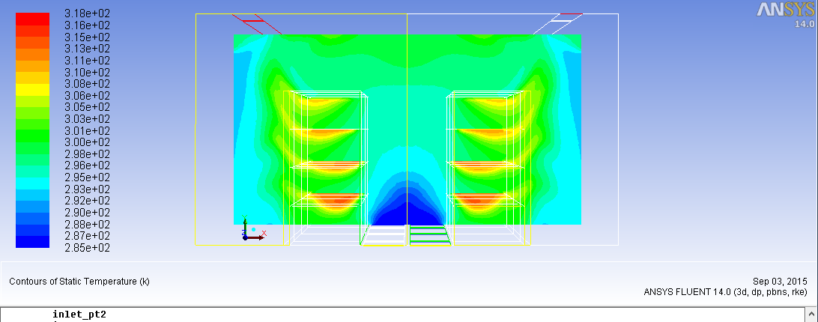

**First rack**

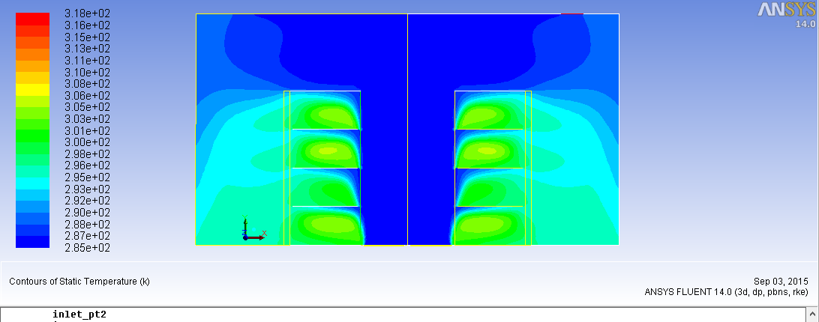

**Middle rack**

**Fig. 7** Temperature distribution at the first and middle racks

*4.2 Enhancement of data center thermal management using cold aisle containment*

In the previous section it was observed that, the low tiles air flow rates at the first racks in the row and the high tiles air flow rates at the middle rack (see Fig. 4) causes cold air bypass at the middle rack and the hot air recirculation at the first rack and this adversely affect RTI and SHI. These problems can be solved by adding a roof top containment of the cold aisle as shown in the dashed line in Fig. 2.

Figure 8 shows the temperature distribution around the first and middle racks after putting cold aisle containment at the top. Comparing these temperature distributions with the ones shown in Fig. 7 (without top containment) reveals that putting cold air containment eliminate the cold air bypass at the middle rack and the hot air recirculation at the first rack.

Figure 9 illustrate the comparison between the indices parameters RTI, SHI and RHI of the two cases, with and without top roof containment. As shown in the figure, adding roof top containment at the cold aisle improve the RTI, SHI and RHI; where both of RTI and SHI decrease to be within the recommended range about 110% and 0.2, respectively. This can be attributed to the elimination of both of the hot air recirculation from the hot aisle to the cold aisle at the first and second racks and the cold air bypass from the cold aisle to the hot aisle at the middle rack.

Figure 10 illustrate the comparison between the indices parameters RCI of the two cases; with and without top roof containment. As shown in the figure, adding roof top containment at the cold aisle improve the RCI; where the RCI HI parameter increase to be within the recommended range about 95 % (acceptable). This also can be attributed to the elimination of the hot air recirculation from the hot aisle to the cold aisle at the first and second racks and the cold air bypass from the cold aisle to the hot aisle at the middle rack.

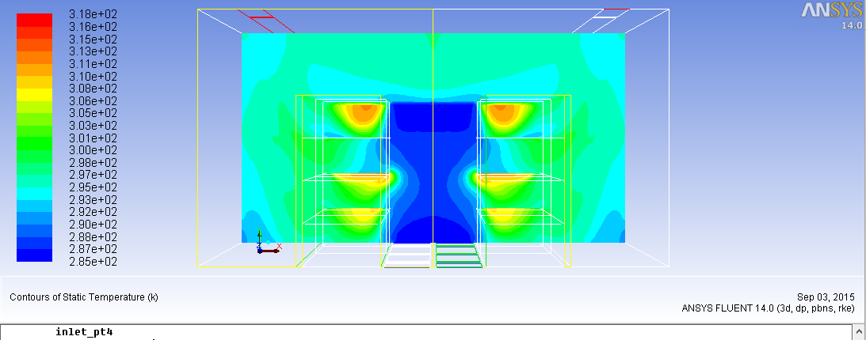

**First rack**

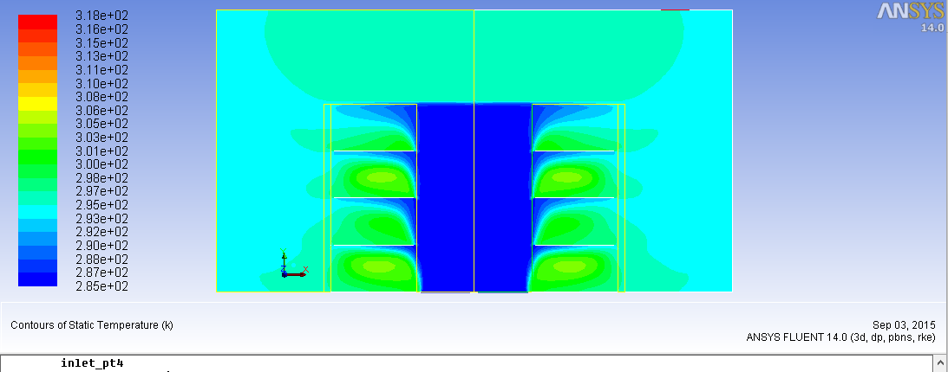

**Middle rack**

**Fig.8** Temperature distribution at the first and middle racks with roof top containment







**Fig.9:** Effect of adding roof top containment of the cold aisle of layout 1 on the RTI, SHI and RHI parameter





**Fig.10:** Effect of adding roof top containment of the cold aisle on RCI

**Conclusions**

A numerical investigations of the performance of air cooled up-flow high density data centers using perforated air tiles have been carried out for different racks and CRAC locations and spacing. Temperature distribution, air flow characteristics particularly air recirculation and bypass, cooling efficiency and thermal managements in data centers are evaluated in terms of the measureable overall performance parameters (RTI, SHI, RHI and RCI). The results showed that:

* The hot air recirculation, cold air bypass and the measurable performance parameters of a rack strongly depend on the rack location and its number in the racks row.
* changing the spacing between the cold aisle and CRAC units slightly change air flow recirculation and bypass.
* Using cold aisle partitions with raised floor decreases the recirculation and bypass of air flow around the middle and first racks in a rack row, respectively and improves the performance of the cooling of data center.

**References**

S. Kang, R.R. Schmidt, K.M. Kelkar, A. Rdmehr and S.V. Patankar. (2000), A Methodology for the Design of Perforated Tiles in Raised Floor Data Centers Using Computational Flow Analysis, *ITherm*.

R. Schmidt, K. Karki, K. Kelkar, A. Radmehr, and S. Patankar. (2001), Measurements and Predictions of the Flow Distribution through Perforated Tiles in Raised Floor Data Centers. Advanced in Electronic Packaging 2001, Proceedings of IPACK’01, and the Pacific Rim/ASME *International Electronic Packaging Technical* Conference and Exhibition in Kauai, Vol. 2, Paper IPACK2001-15728, pp. 905-914.

K. Karki, A. Radmehr, and S. V. Patankar. (2003), Use of Computational Fluid Dynamics for Calculating Flow Rates Through Perforated Tiles in Raised-Floor Data Centers, *International Journal of Heating, Ventialation, Air-Conditioning, and Refrigeration Research*, 9(2), 153-166.

W.A. Abdelmaksoud, H. E. Khalifa, T. Q. Dang, B. Elhadidi, R. R. Schmidt and M. Iyengar. (2012), Experimental and computational study of perforated floor tile in data centers, *ITherm*

S. Kim. (2009), Effectiveness of Specialized Floor Tile Designs on Air Flow Uniformity, BS, State University of New York at Binghamto

K. C. Karki, S. V. Patankar. (2005), Airflow distribution through perforated tiles in raised-floor data centers, *Innovative Research*, Inc., 3025 Harbor Lane North, Suite 300, Plymouth, MN 55447, USA.

K. C. Karki, S. V. Patankar, A. Radmehr. (2003), Techniques for controlling airflow distribution in raised-floor data centers, Proceedings of IPACK03, The Pacific Rim/ASME *International Electronic Packaging*. Technical Conference and Exhibition. July 6-11, Maui, Hawaii, US

R. K. Sharma. (2002), Dimensionless parameters for evaluation of thermal design and performance of large-scale data centers, *Hewlett-Packard Laboratori*

R.R. Schmidt, and E. Cruz. (2004), Cluster of High-Powered Racks within a Raised-Floor Computer Data Center: Effect of Perforated Tile Flow Distribution on Rack Inlet Temperatures, *ASME J. Electron*. Packag.126: 510-518

J. Cho, T. Lim, B. S. Kim. (2009), Measurements and predictions of the air distribution systems in high compute density (Internet) data centers, Yonsei University, Seoul 120-749, South Ko

S. Bhopte, R.R. Schmidt, D. Agonafer, and B. Sammaika. (2006), Optimization of Data Center Room Layout to Minimize Rack Inlet Air Temperature. *Journal of Electronic Packaging*.

K. Zhang, X. Zhang, S. Li, X. Jin. (2014), Experimental study on the characteristics of supply air for UFAD system with perforated tiles, *Energy and Buildings*, 81: 1

J.F. Karlsson, B. Moshfegh. (2005), Investigation of indoor climate and power usage in a data center. [*Energy and Buildings*](http://www.sciencedirect.com/science/journal/03787788),  [37 (10](http://www.sciencedirect.com/science/journal/03787788/37/10)): 1075–10

H.S. Sun, S.E. Lee. (2006), Case study of data centers’ energy performance. [Author Vitae](http://www.sciencedirect.com/science/article/pii/S0378778805001738#vt1) [*Energy and Buildings*](http://www.sciencedirect.com/science/journal/03787788), 38(5) : 522-533

[J. M. Jackson](http://www.sciencedirect.com/science/article/pii/S0360544203000094), [J.G. Koomey](http://www.sciencedirect.com/science/article/pii/S0360544203000094) , [B. Nordman](http://www.sciencedirect.com/science/article/pii/S0360544203000094), [M. Blazek](http://www.sciencedirect.com/science/article/pii/S0360544203000094). (2003), Data center power requirements: measurements from *Silicon Valley. Energy*, 28(8): 837-85

Magnus K. Herrlin. (2009), U.S. Department of Energy, U.S. Data Centers Save Energy Now, *Industrial Technologies Program*, DOE-energy efficiency and renewable energy

TC 9.9, Mission Critical Facilities, Technology Spaces, and Electronic Equipment, Thermal Guidelines for Data Processing Environments, *American Society of Heating, Refrigerating and Air-Conditioning Engineers Inc*. 2008

Magnus K. Herrlin. (2001), Thermal Management in Telecommunications Central Offices, Generic Requirements NEBS GR-3028-CORE, Telcordia Technologi

J. Cho, B.S. Kim. (2011), Evaluation of air management systems thermal performance for superior cooling efficiency in high-density data centers, *Energy and Buildings*, 43: 2145-2155.

S.A. Nada, K. E. Elfeky, Ali M.A. Attia, W.G. Alshaer. (2015), Thermal Management of Electronic Servers under Different Power Conditions, Int. J. of *Emerging trends in electrical and electronic (IJETEE)*, 11 (4), 145-150

R. K. Sharma. (2002), Dimensionless parameters for evaluation of thermal design and performance of large-scale data centers, *Hewlett-Packard Laboratories*.

1. *Corresponding author’s Mob: +201141577879